Taking a look at each evidence-informed approach for the development of mathematical understanding in our youngest children.
Understanding one approach at a time.
“Using multiple approaches together could aid children’s mathematical development”
EEF evidence store
Key language to use with children to promote fluency with numbers:
Let’s check how many there are
Naming and labelling numerals
Number songs such as 1,2,3,4,5 once I caught a fish alive

Approach 2 from the EEF evidence store
Promoting Fluency with Numbers
Becoming fluent with the count sequence
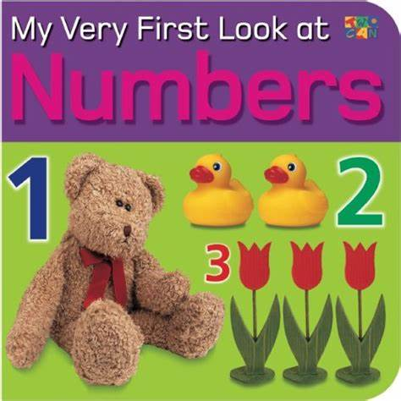
Using texts can support this approach as well as making use of daily routines to sing, chant and recognise numbers and numerals. Make use of key moments in the day to chant the count sequence forwards and backward

counting 1,2,3 counting 1,2,3,4,5 chanting numbers backwards

