
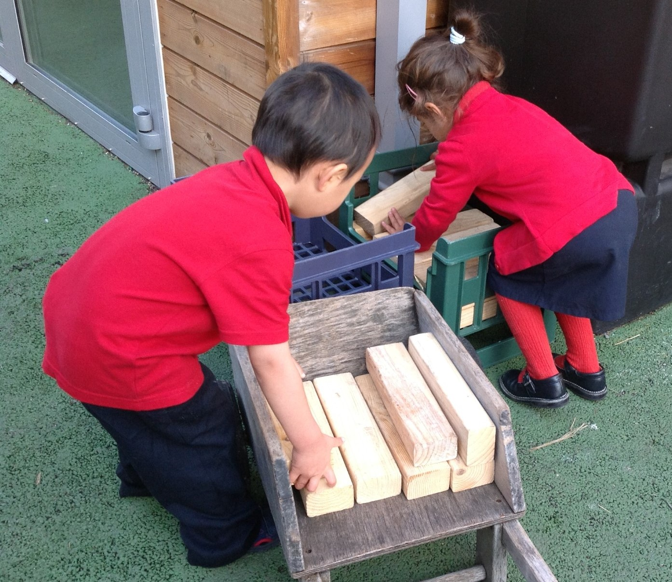

Positive Behaviour Management Ideas
Tips from London South EYSPH
Here are some useful tips for staff to help implement positive behaviour management.
It is a practical guide in how adults adapt their language to make the focus positive, label behaviours that are desirable and resolve conflicts in a calm fashion.
It can be added to and should be used as a working resource.

Developing pride by labelling achievements:
- “I love the way you added so much detail to your painting. You put a lot of thought into that.”
- “It was very kind of you to give a bit of play dough to ________ who just joined us.”
- “I’d love you to tell me about this amazing construction.”
Remember, if you did not see something you cannot judge or intervene. You can facilitate children talking to each other and help develop their language so they can resolve the issue independently. If a child said they saw or experienced something they are in the best position to resolve it.
We can teach them to label, “You snatched my pen and that makes me feel unhappy. Next time just ask and I’ll show you where the pens are.”

Labelling behaviour when things go wrong:
- What happened to you?
- Tell me your story.
- You have………….
- Only give two choices.
- You can either……….and………..
- Or you can choose to continue……. and……….
Example:
“Pushing _____ off the bike has made_____ very sad. I also feel sad because I want everybody to feel safe here.”
“You either stop pushing people off the bikes and stay out here to wait for a turn or you can choose to go somewhere else if you cannot wait.” Alternatively use visuals or signs with minimal language depending on child.
“How do you think we can make this fair?” Children often have the best solutions, are we making sure we truly value their opinions?

Ways to avoid saying ‘well done’
- I like the way you……..
- What an interesting way to ……….
- Tell me about your picture……..
- I’d love to know how you made ……….
- What a great idea….
- I love the solution you came up with…
- I can see you took a long time making……….
- Tell me more about what you have made………..

