Communication Friendly Setting - A journey of discovery

This blog was written by Martin Cumming of St Paul’s Nursery School, York.

Martin has worked at St Paul’s Nursery School in York for almost five years and has been teaching for almost 18 years. He is a trained teacher, SENCO, Lead Communication Practitioner and Assistant Head Teacher. Martin is passionate about creating neuro affirming practice within settings and has a real interest in neuro diversity and speech, language and communication development.

Part Two – ‘A Gardener’s Guide to Implementation’
I promise that part two of our blog on Communication Friendly Setting (CFS) will not start with a quote from Ronan Keating! However, I will quote the Early Years Foundation Stage Framework that states ‘The development of children’s spoken language underpins all seven areas of learning and development. Children’s back-and-forth interactions from an early age form the foundations for language and cognitive development.’ (DFE 2021) Something to reflect on whilst delving deeper into our Communication Friendly Setting Journey and looking at how we put the intent into practice.

The EEF guidance on implementation sets out a clear cycle of how to ensure what you are trying to put into place in your setting is right and that you ensure your setting is ready for it.
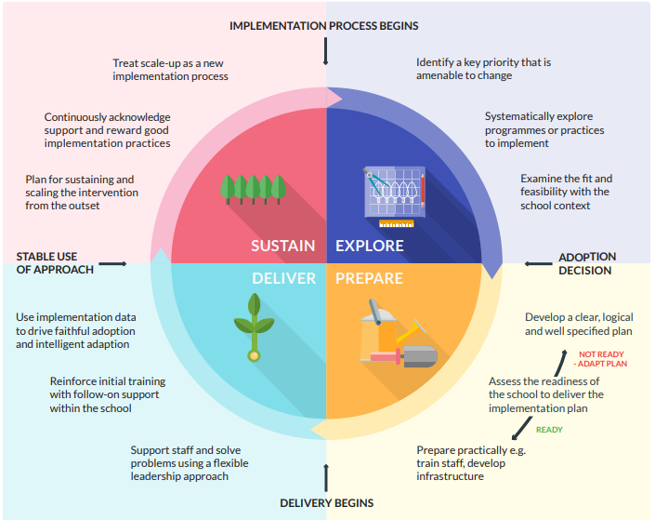
It follows the process of ‘explore, prepare, deliver, sustain’ (EEF 2019) In the last part of this blog we looked at the explore part of the process. Thinking about what programme we wanted to put into place and whether or not that was the best thing for our setting. The answer, as I am sure you have already guessed, was yes, CFS was the correct approach to take. It was the ‘best fit’ for the work that we wanted to undertake around speech language and communication in Nursery.
The staff were trained and ready to start the next part of the journey.

I think the analogy that comes to mind is that of trying to grow a plant. Something that can be trial and error if you are not quite prepared.


We have the seed, in this case the idea, implementing the Communication Friendly Setting and the ELKLAN approach into nursery. Knowing that if we get this part of the journey correct we will see an impact on speech, language and communication in children who have been affected by the pandemic. The necessary resources are in place and the staff were ready.
The next part of the cycle was deliver how we were going to make our seed grow.
The first thing we looked at in this part of the implementation phase was adult child interactions. How we encourage language through play within the areas of provision in nursery. ELKLAN suggest that the average 6 year old has a vocabulary of around 14000 words, which is mind blowing in itself. However, when you break this down children between the ages of 18 months and 6 years have to learn 8 new words a day! (We will look a little deeper at this later) This is a lot of vocabulary to learn, meaning every interaction with a child in our setting needed to be high quality, and focussed on language development through play.

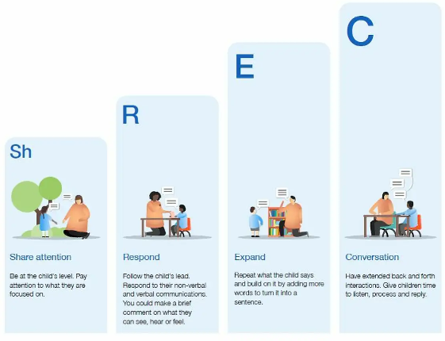
This approach to language and interaction is reflected in the EEF ShREC approach, Fliss James (2022) suggests that by adults modelling language and pitching it just above the level of where a child is working, promotes new vocabulary and the scaffold of how to use it. This will hopefully then be used in the child’s further play and interactions with others.
Within our own setting we have found this model an easy aid to follow when thinking about how we develop language and interaction and it links well with the ELKLAN CFS approach.
This embodies what the EYFS Statutory Framework states that… ‘Through conversation, story-telling and role play, where children share their ideas with support and modelling from their teacher, and sensitive questioning that invites them to elaborate, children become comfortable using a rich range of vocabulary and language structures (DFE 2021)

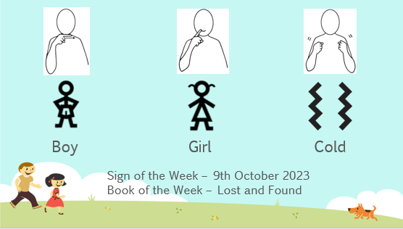
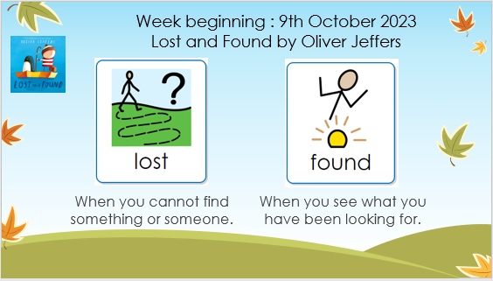
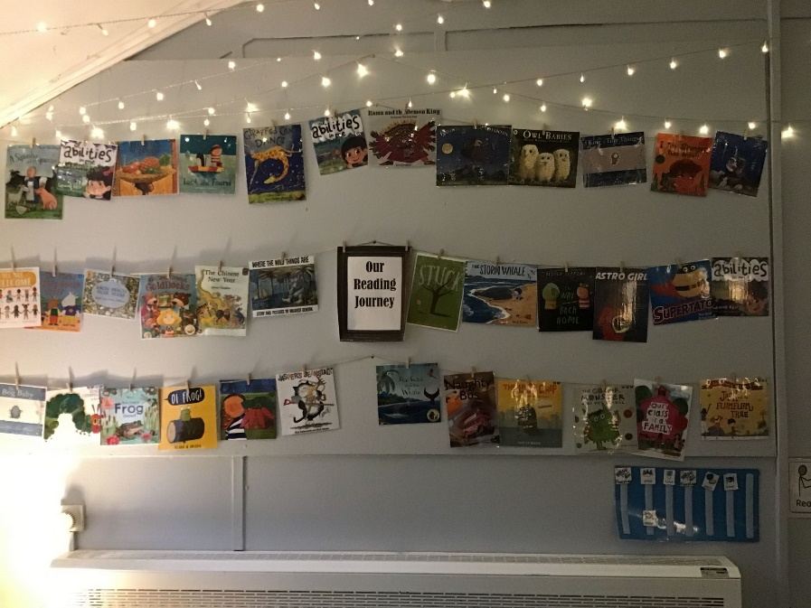

Immersing children in stories was our next step. During the pandemic, in lock down, we re-evaluated our approach not only to our curriculum but also to the texts that the children were exposed to at their time in nursery. As a staff we thought of our favourite children’s texts and asked parents and children for theirs. We then looked at how these books could be used to teach the curriculum, matching them up with the statements from development matters. We ended up with our reading journey or books of the week. These stories were chosen because they were fun, engaging for children, linked in with what we wanted the children to learn but most of all had language that we wanted to model. Of course, these just form our core reading. We ensure that the children are read to at every possible opportunity, that a range of fiction and non-fiction texts are available and that books are displayed in a way that encourages children to pick them up and delve in. As ELKLAN suggest children need to learn 8 new words per day so as part of this ‘word diet’ we choose two words of the week that children are taught in group times, learn the definition (modelling how to use them) and we then display them in setting and share with parents. This goes hand in hand with the Makaton signs of the week, using alternative forms of communication, as some children in our setting do, to build language and communication skills.
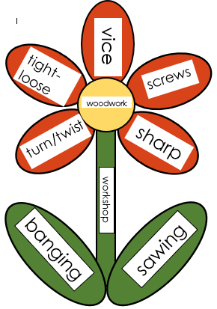

Parental Contribution was a vital part to the roll out of CFS in nursery. As ELKLAN suggest children need to be exposed to new language daily. This leads to how we can work in collaboration with parents. It is suggested that of these 8 words a day, five are learnt in setting and three are learnt at home. So how did we support parents in this and how did parents support us. We post our words of the week and our story of the week using our Famly App allowing the parents to see what we will be learning at nursery in the coming week. But we felt that we could engage further. ELKLAN suggest the use of language flowers and example of which is below. These can be used to display language in the areas of provision around the setting. These five words were used to display language that practitioners could model and then observe being used. However, we felt that to engage parents we wanted their input on the language that we put on these flowers. We sent a google form via email and asked for contributions, which parents sent back, and the words were then put into the stem and the leaves of the flower. A little way for parents and setting to support language development together.

Developing language through all interactions was important but we wanted to take this a step further. We wanted to specifically teach children language concepts in group times. We had been using the Wellcomm Toolkit as part of our assessment framework in setting, so using their ‘Big Book of Ideas’ to develop language knowledge was also key. We looked at where, on average, the group of children were scoring on Wellcomm and then translated this information into what concepts needed teaching. The Big Book of Ideas gave suggested strategies to help to deliver this. This truly helped increase children’s understanding of language and we noticed a marked improvement in spoken and receptive language in setting.

Intervention was also key. When we identified children who were significantly below expected levels in speech and language we used trained staff to skilfully work alongside them either in small groups or in one to one time. Using activities that worked along the principles of ELKLAN but also using the Early Talkboost intervention. This intervention, lead by one of our ELKLAN level 3 trained practitioners saw great results in raising speech and language in the target group of children. Leading to greater interactions with their peers when playing in areas of provision.


Sustaining and maintaining…
Reflecting back to the analogy of growing a seed. I am not green fingered at all. As I sit and write this, I am staring at a plant that my wife asked me to water about three weeks ago but still hasn’t been done, you can imagine what the plant looks like! If we don’t maintain our focus on communication and language and take our eye off the end goal then new shoots of growth do not appear and children stop making the desired progress. We must keep watering and nurturing this plant to see growth. We ensure that we talk about speech and language in staff meetings and when talking about children with their key practitioners. We ensure that we ‘prioritise the development of communication and language’ (EEF 2021) through all areas of the curriculum, keeping the ideas of ELKLAN and the CFS at the forefront of our minds. Sorry to mention the ‘O’ word but we recently had an Ofsted inspection and one of the deep dives that they carried out was in the are of Communication and Language. This journey that we have been on, through gaining the Communication Friendly Setting status, helped us to articulate to the inspectors the impact that Covid had had on our children, how we identified it as an area of need and how we implemented the steps to help support the speech and language development of the children in our care. Turning 48% of children working below expected standards in speech, language and communication to almost 80% working at. We will look in part three at the impact that this has had not only on C&L but also other aspects of the curriculum.
Thank you for your time in reading my ‘Gardener’s Guide to Implementation’ I am off to take a leaf out of my own book and water that plant before it turns into compost, or I get told off!!

Time to reflect:
What Speech and Language interventions do you need to take a fresh look at?
How do you display language around the setting not just for children but also for staff?
Do some areas of practice need pruning and others watering?

Further reading and references
DFE (2023), Statutory Framework for the Early Years Foundation Stage
Education Endowment Foundation (2021), Preparing for Literacy – Improving communication, language and literacy in the early years
Education Endowment Foundation (2021), Putting Evidence to Work – A School’s Guide to Implementation
James, Fliss (2022), EEF Blog: The ShREC approach – 4 evidence-informed strategies to promote high quality interactions with young children

Further information regarding ELKLAN Early Years Communication Friendly Settings please click below.
Communication Friendly Settings - Early Years | Elklan Training Ltd

