**BLOG FOR THAMES VALLEY EY HUB**

**1600 words**

**Subitising – what it is and why it is important for early mathematics.**

**Dr Helen J Williams March 2024**

Over the last 20 years there have been significant developments in our understandings of how 3-7-year-olds learn mathematics effectively. Many of the international studies published during this period have practical relevance for the mathematics we prepare in pre-school settings, Reception and KS1 classrooms. One significant development in our understanding of the early learning of number is the recognition that establishing a robust connection between *numbers* and *quantities* is not simple and that these connections continue to be forged between the ages of 5 and 9 years of age:

*“Because the connections between quantities and numbers are many and varied, learning about these connections could take three to four years in primary school.*” (Nunes and Bryant, 2009: 4)

It is important that practitioners continue to provide plentiful and varied opportunities for children to organise, estimate, count, compare, share out and label groups of objects, in many contexts and for different purposes well into Y2.

Figure 1 (4 gold beans)

Somewhat contrarily, research from the 1990s onwards (Clements 1999, Clements and Sarama 2021) indicates that it is unhelpful for adults to ask children to ‘count to check’ when they have already *subitised.* Subitising is the direct perceptual apprehension of the numerosity of a group. It stems from a Latin word meaning ‘suddenly’. This ability to recognise a small amount without counting one-by-one, has been researched since the 1900s and can be more accurate than counting, as it focuses on both the whole and the unit, see for example figure 1: “*I see four there and I’m four!*”. Research suggests that even very young children possess and spontaneously use subitising to number a small set and that subitising might emerge before counting (Klein and Starkey, 1988). This is *perceptual subitising*, an ability we have and share with some other mammals, to recognise up to four or five items without having to count these. It is difficult to perceptually subitise more than four items without arranging these into a recognisable or iconic arrangement, such as that on dice. *Conceptual subitising* builds on our perceptual ability, to recognise the numerosity of larger groups without counting one-by-one: “*There’s seven, look, three here and four here*” (see figure 2). These understandings link into important later work combining and partitioning numbers (Early Intervention Foundation 2018).

Figure 2 (7 daises)

Regularly presenting collections and images of small numbers of objects, such as the small number of beans in figure 1, using objects of the same type and colour to focus on the amount, develops children’s confidence in recognising and naming small quantities of different items, and different arrangements of 3,4 and 5. We can also encourage subitising in-the-moment, as children play (see figure 2 – including outdoors). Dice and domino patterns are easily subitised and children should be encouraged to recognise these without ‘counting to check’. We can develop this into games, including those that involve ‘glimpsing’ an amount; for example, holding up paper-plates with a small number of glued buttons to name, or to match and sort.

Figure 3. Maeve Birdsall

Providing opportunities for children to make sense of what they are being taught is necessary and it is worth examining our provision to see if this supports children in exploring mathematical ideas such as subitising, see for example, figure 3. We might consider providing a range of small loose parts with partitioned containers such as egg-boxes and 5-frames to fill, along with numeral cards, a relevant picture book, along with clipboards and pens for recording; or an interest board with a different visual provocation each week together with a prompt card for adults: ‘What do you see?’ ‘How do you see it?’ ‘What do you wonder?’ ‘What’s the same?’ ‘… different?’ ‘Which one do you think doesn’t belong?’ ‘Why?’ (see figure 4 images of 7). These are important, unpressurised opportunities for children to practice recognition of quantities and develop their number knowledge and confidence independently.

Gradually, as children’s perceptual subitising develops, larger amounts, such as the ducks in figure 5, lead to valuable discussions with children decomposing and re-composing numbers in different ways. As there is no ‘one, right’ way of seeing these 8 ducks, this is a low-risk, safe atmosphere to support mathematical thinking. Children might see 3 at the top and another 3 and 2 underneath; others might see 5, with 3 on top, and so on. Can they see 4 and 4? It is beneficial to discuss what we see in both organised and random arrangements. By spending time inviting children to ‘say what you see’, and ‘Can you help us see what you see?’, we are communicating that we can all contribute to important mathematical discussion, and notably, that mathematics is flexible.

Figure 5 (8 ducks)

Often the importance of subitising is seen as ‘ending’ at Reception. This is a mistake, as conceptual subitising plays a key role in understanding the composition of numbers.

*“But how is it that people see an eight-dot domino and 'just know" the total number? They are using (conceptual) subitizing. Conceptual subitizing plays an advanced-organizing role. People who "just know" the domino's number recognize the number pattern as a composite of parts and as a whole.”*

(Clements 1991: 3)

It is important that we do not move too quickly to symbols at this point, which is a mistake many make. If we build on the children’s understanding of different amounts using images and manipulatives, and work on children describing HOW they see the larger number, we will be building a firm foundation for understanding addition and subtraction and how larger numbers are composed of smaller numbers (forget the cherry diagrams!). There is enormous value in not moving too fast.

Numerical subitising is one part of the skill of visualising, central to successful mathematics. We can support the development of this skill across areas of mathematics such as shape, space and pattern by selecting shape or pattern images for our maths chats, for example, asking ‘What do you notice?’ ‘How do you see it?’ about a simple pattern or Duplo model; and maybe asking, ‘If I show you a glimpse, do you think you could make it?’ For two examples, see figure 6.

) 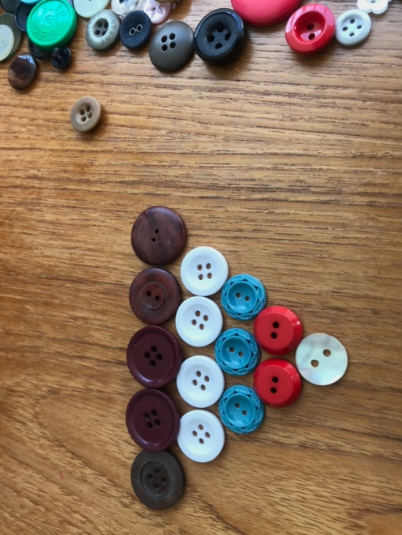 Figure 6 (Duplo and buttons)

Finally, what adult interactions are the most effective for learning mathematics? Whilst mathematics research is clear that early mathematics must contain both high-quality free play and high-quality teaching (Anthony and Walshaw 2007, Clements and Sarama 2021, Downton et al 2020), Skene and her colleagues published a meta-analysis of play research in 2022 and found that ‘guided play’ rather than free play or direct instruction, is the most effective pedagogy for early mathematics, providing a ‘powerful vehicle’ for early mathematical learning (Skene et al 2022). They categorised guided play as having three fundamental characteristics (Skene 2022, Weisberg et al 2013):

* The adult is clear about what is to be learned,
* The child should have choice and agency – whoever initiates the task, at some point it should be child led, and
* The adult is flexible with their guidance.

This offers an important take-away for our teaching and adult- initiated mathematics, to include space for children to make decisions about what takes place, even when we direct the task initially.

Mathematics in the early childhood years has been found to be surprisingly important for wider development through life, as well as being predictive of later mathematical achievement (Cllements and Sarama 2021) and children’s understanding of number during the preschool years is consistently associated with their mathematical achievement in primary and secondary school (EIF 2018, Nunes and Bryant 2009). Both how we work with children mathematically and what we provide are as important as each other.

**Useful websites:**

* The UK-based Early Childhood Mathematics Group [https://earlymaths.org](https://earlymaths.org/), and <https://nrich.maths.org/early-years>
* Birth to Five Matters: <https://birthto5matters.org.uk>

Two US-based groups of educators and researchers:

* [https://earlymath.erikson.edu](https://earlymath.erikson.edu/)
* [https://dreme.stanford.edu](https://dreme.stanford.edu/)

Podcast on supporting early mathematical thinking:

* <https://www.ncetm.org.uk/podcasts/how-early-years-children-develop-mathematical-thinking/> Sue Gifford and Viv Lloyd

***Dr Helen J Williams is an independent educational consultant who specialises in the learning and teaching of Early Years and KS1 mathematics. She has a special interest in working alongside colleagues developing effective playful curricula opportunities. Her book ‘Playful Mathematics for Children 3 to 7’ was published by Sage in 2022 and won Professional Book of the year at the Nursery World awards later that year. Helen tweets as: @helenjwc***

**References**

Anthony, G., and Walshaw, M. (2007). Effective Pedagogy in Mathematics/Pangaram: Best Evidence Synthesis Iteration [BES]. Wellington, New Zealand: New Zealand Ministry of Education

Clements, D.H. (1999). Subitizing: What Is It? Why Teach It? Teaching Children Mathematics 5(7):400-405 <https://www.researchgate.net/publication/258933161_Subitizing_What_Is_It_Why_Teach_It>

Clements, D.H. and Sarama, J. (2021). 3rd Edition. *Learning and Teaching Early Math: The learning trajectories approach*. NY: Routledge

Downton A., MacDonald A., Cheeseman J., Russo J., McChesney J. (2020). Mathematics Learning and Education from Birth to Eight Years. In: Way J., Attard C., Anderson J., Bobis J., McMaster H., Cartwright K. (eds) *Research in Mathematics Education in Australasia 2016–2019*. Singapore: Springer

Early Intervention Foundation (2018). *Key Competencies in Early Cognitive Development: Things, people, numbers and words.* London: EIF

Klein, A, and Starkey, P. (1988). ‘Universals in the Development of Early Arithmetic Cognition.’ In *Children's Mathematics*, edited by Geoffrey B. Saxe and Maryl Gearhart, 27-54. San Francisco: Jossey-Bass

Nunes, T. & Bryant, P. (2009). *Key Understandings in Mathematics Learning: Paper 2: Understanding Whole Numbers.* London: Nuffield Foundation

Skene, K., O’Farrelly, C., Byrne, E., Kirby, N., Stevens, E. & Ramchanandi, P. (2022). *Can guidance during play enhance children’s learning and development in educational contexts?* PEDAL Research: Cambridge, UK

Weisberg, D., Hirsh-Pasek, K., & Golinkoff, R. (2013). Guided play: Where curricular goal meet a playful pedagogy. *Mind, Brain, and Education*, *7*: 104–112

Williams, H.J. (2022). *Playful Mathematics for Children 3 to 7.* London: Sage/Corwin