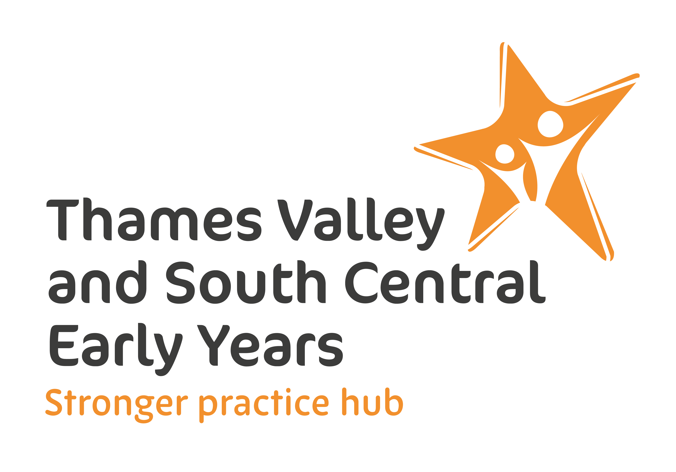
Elklan Communication Friendly Setting Programme for Thames Valley and South Central Stronger Practice Hub:

Expression of Interest

School or setting name
Local Authority area
Headteacher or Manager
Headteacher or Manager’s email
Headteacher or Manager’s telephone
School or setting contact (if not Headteacher/Manager)
Contact’s email
Contact’s telephone number
I have read and agree to Elklan’s Privacy Policy | Yes/No
Name of proposed Lead Communication Practitioner 1, who will participate in the training
email
Preferred time of day for live webinars | 8am/10am/noon/2pm/3.30pm/5pm
Name of proposed Lead Communication Practitioner 2, who will participate in the training
email
Preferred time of day for live webinars | 8am/10am/noon/2pm/3.30pm/5pm

Please complete and return the form to alex@elklan.co.uk
There are very limited places so we encourage you to do this as soon as possible.

