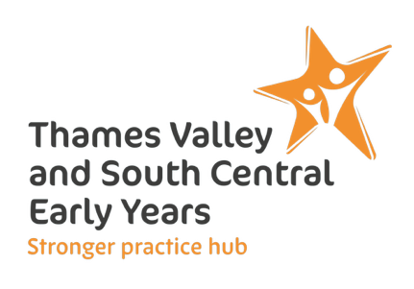
Elklan Communication Friendly Setting Programme for Thames Valley and South Central Stronger Practice Hub

Expression of Interest

School or setting name
Local Authority area
Headteacher or Manager
Headteacher or Manager’s email
Headteacher or Manager’s telephone
School or setting contact (if not Headteacher/Manager)
Contact’s email
Contact’s telephone number
I have read and understood the CFS information document | Yes/No
I have read and agree to Elklan’s Privacy Policy | Yes/No
Name of proposed Lead Communication Practitioner 1, who will participate in the training
Practitioner 1 email
Preferred time of day for live webinars | 8am/10am/noon/2pm/3.30pm/5pm
Does Practitioner 1 have existing level 3, ‘A’ level or equivalent | Yes/No
Name of proposed Lead Communication Practitioner 2, who will participate in the training
Practitioner 2 email
Preferred time of day for live webinars | 8am/10am/noon/2pm/3.30pm/5pm
Does Practitioner 2 have existing level 3, ‘A’ level or equivalent | Yes/No

Please complete and return to Kirsten@elklan.co.uk by Wednesday 10th December.
There are very limited places so we encourage you to do this as soon as possible.



